***Computer Characteristics***

Computers are machines designed to process, electronically, specially prepared pieces of information which are termed data. Handling or manipulating the information that has been given to the computer, in such ways as doing calculations, adding information or making comparisons is called processing. Computers are made up of millions of electronic devices capable of storing data or moving them, at enormous speeds, through complex circuits with different functions.

All computers have several characteristics in common, regardless of make or design. Information, in the form of instructions and data, is given to the machine, after which the machine acts on it, and a result is then returned. The information presented to the machine is the input; the internal manipulative operations, the processing; and the result, the output. These three basic concepts of input, processing, and output occur in almost every aspect of human life whether at work or at play.

For example, in clothing manufacturing, the input is the pieces of cut cloth, the processing is the sewing together of these pieces, and the output is the finished garment.

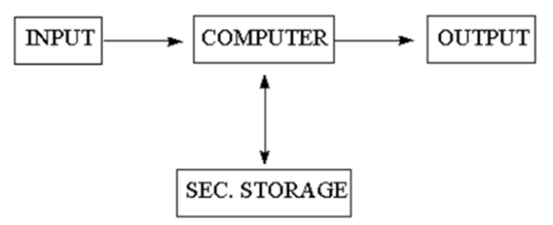

Figure shows schematically the fundamental hardware components in a computer system. The centerpiece is called either the computer, the processor, or, usually, the central processing unit (CPU). The term ‘computer’ includes those parts of hardware in which calculations and other data manipulations are performed, and the high-speed internal memory in which data and calculations are stored during actual execution of programs. Attached to the CPU are the various peripheral devices such as card readers and keyboards (two common examples of input devices). When data or programs need to be saved for long periods of time, they are stored on various secondary memory devices or storage devices such as magnetic tapes or magnetic disks.

Computers have often been thought of as extremely large adding machines, but this is a very narrow view of their function. Although a computer can only respond to a certain number of instructions, it is not a single-purpose machine since these instructions can be combined in an infinite number of sequences. Therefore, a computer has no known limit on the kinds of things it can do; its versatility is limited only by the imagination of those using it.

In the late 1950s and early 1960s when electronic computers of the kind in use today were being developed, they were very expensive to own and run. Moreover, their size and reliability were such that a large number of support personnel were needed to keep the equipment operating. This has all changed now that computing power has become portable, more compact, and cheaper.

In only a very short period of time, computers have greatly changed the way in which many kinds of work are performed. Computers can remove many of the routine and boring tasks from our lives, thereby., leaving us with more time for interesting, creative work. It goes without saying that computers have created whole new areas of work that did not exist before their development.

***Computer capabilities and limitations***

Like all machines, a computer needs to be directed and controlled in order to perform a task successfully. Until such time as a program is prepared and stored in the computer's memory, the computer 'knows' absolutely nothing, not even how to accept or reject data. Even the most; sophisticated computer, no matter how capable it is, must be told what to do. Until the capabilities and the limitations of a computer are recognized, its usefulness cannot be thoroughly understood.

In the first place, it should be recognized that computers are capable of doing repetitive operations. A computer can perform similar operations thousands of times, without becoming bored, tired, or even careless.

Secondly, computers can process information at extremely rapid rates. For example, modern computers can solve certain classes of arithmetic problems millions of times faster than a skilled mathematician. Speeds for performing decision-making operations are comparable to those for . arithmetic operations but input-output operations, however, involve mechanical motion and hence require more time. On a typical computer system, cards are read at an average speed of 1000 cards per minute and as many as 1000 lines can be printed at the same rate.

Thirdly, computers may be programmed to calculate answers to whatever level of accuracy is specified by the programmer. In spite of newspaper headlines such as ‘Computer Fails’, these machines are very accurate and reliable especially when the number of operations they can perform every second is considered. Because they are man-made machines, they sometimes malfunction or break down and have to be repaired. However, in most instances when the computer fails, it is due to human error and is not the fault of the computer at all.

In the fourth place, general-purpose computers can be programmed to solve various types of problems because of their flexibility. One of the most important reasons why computers are so widely used today is that almost every big problem can be solved by solving a number of little problems – one after another.

Finally, a computer, unlike a human being, has no intuition. A person may suddenly find the answer to a problem without working out too many of the details, but a computer can only proceed as it has been programmed to.

Using the very limited capabilities possessed by all computers, the task of producing a university payroll, for instance, can be done quite easily. The following kinds of things need be done for each employee on the payroll. First: Input information about the employee such as wage rate, hours worked, tax rate, unemployment insurance, and pension deductions. Second: Do some simple arithmetic and decision making operations. Third: Output a few printed lines on a cheque. By repeating this process over and over again, the payroll will eventually be completed.